**DIGESTIVE SYSTEM AND ITS ASSOCIATED ORGANS**

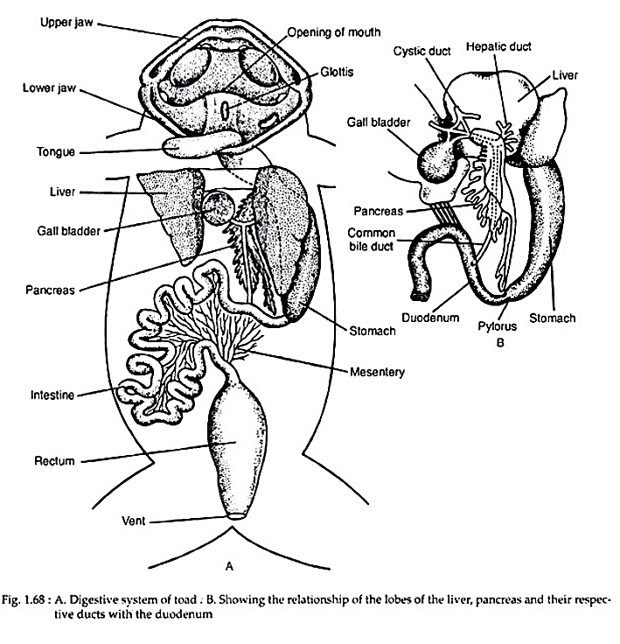

**Fig. 1.68**: **A**. *Digestive system of a toad*. **B**. *Showing relationship of the liver, pancreas and their respective ducts with the Duodenum.*

**ARTERIAL SYSTEM OF A TOAD**

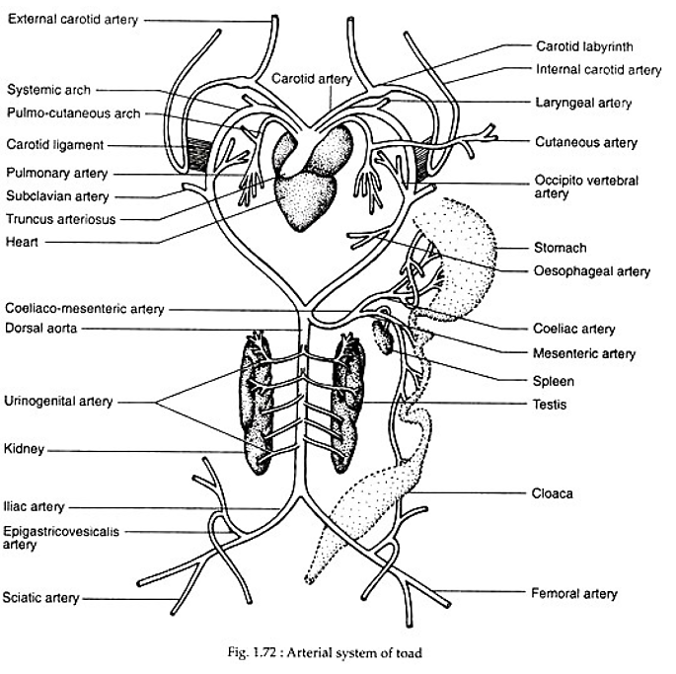

**VENOUS SYSTEM OF A TOAD**

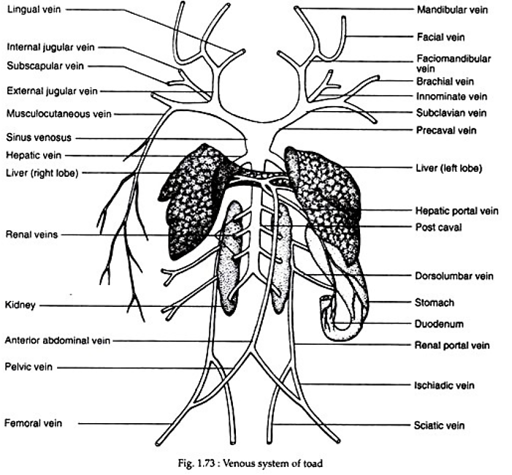

**TEST YOURSELF**

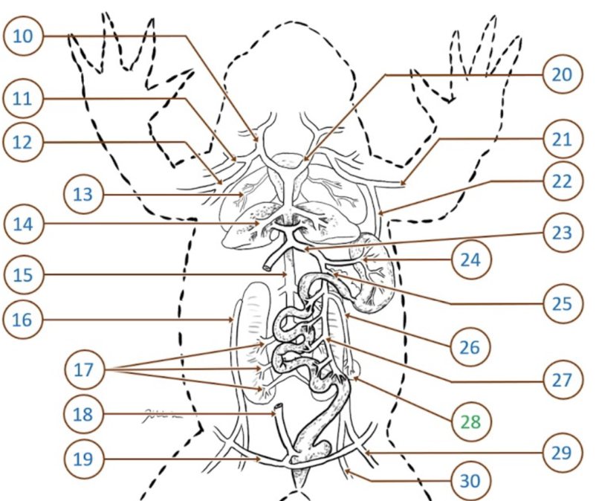

**Qn.1**: Name arteries 10-30

1. ……………………………………………..
2. ……………………………………………..
3. ……………………………………………..
4. ……………………………………………
5. ………………………………………….
6. …………………………………………….
7. …………………………………………….
8. ……………………………………………..
9. ……………………………………………..
10. ……………………………………………..
11. ……………………………………………
12. ……………………………………………….
13. ……………………………………………….
14. ………………………………………………
15. ………………………………………………
16. ………………………………………………
17. …………………………………………….
18. ……………………………………………….
19. ……………………………………………….
20. ……………………………………………….
21. ……………………………………………….

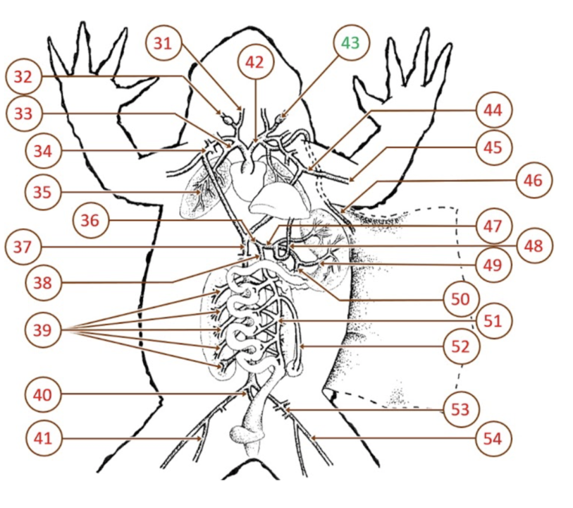

**Qn.1**: Name arteries 31-54

1. ……………………………………………..
2. ……………………………………………..
3. ……………………………………………..
4. ……………………………………………
5. ………………………………………….
6. …………………………………………….
7. …………………………………………….
8. ……………………………………………..
9. ……………………………………………..
10. ……………………………………………..
11. ………………………………………………
12. ……………………………………………….
13. **……………………………………………..**
14. **……………………………………………….**
15. ……………………………………………
16. ……………………………………………….
17. ……………………………………………….
18. ………………………………………………
19. ………………………………………………
20. ………………………………………………
21. …………………………………………….
22. ……………………………………………….
23. ……………………………………………….
24. ……………………………………………….